**Faculty of Computer Science & Engineering**

Project Report on

**Web application on job portal**



**Course Code: CIT-220**

**Course Title: Web Programming Project**

**Submitted by**

**Prosenjit Mondol**

ID: 2102049

REG: 10176

Session: 2021-22

**Submitted to**

**Dr. Md. Samsuzzaman Sobuz**

Professor

Department of Computer and Communication Engineering

Patuakhali Science and Technology University

**Golam Md. Muradul Bashir**

Professor

Department of Computer and Communication Engineering

Patuakhali Science and Technology University

# Table of Contents

1. Abstract…………………………………………………………………………………………………………………………………………… 3
2. Introduction 3
   1. Introduction……………………………………………………………………………………………………………………………………. 3
   2. Motivation………………………………………………………………………………………………………………………………….…… 4
   3. Existing System…………………………………………………………………………………………………………………………….… 4
   4. Our System……………………………………………………………………………………………………………………………….…… 5
   5. Objectives………………………………………………………………………………………………………………………………….…. 5
3. Requirement……………………………………………………………………………………………………………………………………. 6
   1. Hardware Requirements 6
   2. Software Requirements 6
   3. Requirement Analysis 7
4. System Analysis 8
   1. Flowchart 8
   2. Entity-Relationship Diagram 9
   3. Schema Diagram 10
5. System Design 11
   1. Features 11
   2. User Login Sequence 11
   3. Project Showcase (Front-End) 12
   4. Project Showcase (Back-End) 15
6. Coding 16
   1. File Structures 16
7. Conclusion 17

**ABSTRACT**

In today’s fast-evolving technological landscape, the demand for streamlined and efficient digital solutions is more pressing than ever. While users seek simplicity and reliability, many existing systems remain outdated and heavily reliant on manual operations. This is especially true in the employment sector, where traditional methods of job recruitment and application still prevail. To address these inefficiencies, there is a growing need to embrace technology that simplifies the process for both employers and job seekers. Therefore, I have developed a **Job Portal System** that facilitates the easy management of job listings, applications, and user accounts. To understand the current challenges, I conducted surveys with recruitment officers and applicants, and discovered that most processes still involve paper-based documentation, leading to data loss, storage issues, and overall inefficiency. Manual sorting of applications is time-consuming and prone to errors. In response to these challenges, I designed a web-based system that automates these tasks, offering a centralized, user-friendly platform for job management. The system is developed using **PHP**, **HTML**, **CSS**, **JavaScript**, and **MySQL**, and is deployed and tested using the **XAMPP** stack (Cross-Platform, Apache, MariaDB, PHP, and Perl). This project not only reduces paperwork and storage needs but also enhances accessibility, searchability, and data security, ultimately making the recruitment process faster and more efficient for all users.

**INTRODUCTION**

**2.1 Introduction:**

This is a system designed to provide job opportunities to a wide range of users including fresh graduates, experienced professionals, and employers seeking the right candidates. The existing systems such as “online job portals” offer employment services remotely and at a minimal cost, making them highly accessible. Inspired by this concept, our system aims to take it a step further by developing a fully automated, easy-to-use **Job Portal System** that simplifies the job search and recruitment process for all users.

Our main objective is to build a complete, low-cost online job portal that functions efficiently and effectively. The system will allow employers to post job openings and manage applications, while job seekers can browse job listings, upload resumes, and apply for jobs—all without the need to visit any physical office. By ensuring a user-friendly interface and seamless experience, this system will reduce paperwork, save time, and make job hunting and hiring more convenient and organized for everyone involved.

**2.2 Motivation:**

In today’s competitive job market, both job seekers and employers face numerous challenges in connecting with the right opportunities and talent. In the context of Bangladesh, the majority of job seekers still rely on traditional methods like newspapers or personal recommendations to find work, while companies often struggle to reach qualified candidates efficiently. Meanwhile, the use of the internet has significantly increased, especially among the educated population, making online platforms the preferred choice for collecting information and accessing services.

However, despite this growing reliance on the internet, there is still a lack of a comprehensive and user-friendly online job portal that effectively serves the needs of all stakeholders — **job seekers**, **employers**, and **administrators**. Existing platforms may focus on one group more than the others, resulting in incomplete or inefficient services. This creates a clear need for a complete, automated solution that simplifies the job recruitment process from all perspectives.

Our motivation for building this **Job Portal System** comes from the vision of creating an all-in-one platform where:

* **Candidates** can easily register, create profiles, browse job listings, and apply for positions.
* **Companies** can post job vacancies, review applicants, and find the right candidates quickly.
* **Administrators** can manage and monitor the entire system, handle user data, and generate detailed reports for analysis and improvement.

By combining all these features into a single, efficient web-based solution, the system aims to enhance the entire hiring experience and bring convenience, transparency, and efficiency to the job market.

**2.3 Existing System:**

Currently, most companies and job seekers in Bangladesh depend on manual methods for hiring and job searching. Job seekers typically go through newspapers or visit offices physically, while employers collect CVs through email or hand-delivery. The process of storing candidate information, tracking job applications, and managing recruitment details is still largely paper-based or done using basic spreadsheets. This results in a slow and unorganized system with a high chance of data loss and duplication.

Most traditional systems offer only text-based interfaces with limited automation, making them difficult to use and manage, especially for users with minimal technical skills. Communication between candidates and companies is often delayed, and there is no proper tracking of applications or user interactions. Additionally, administrators have no centralized control, and report generation becomes a complex and time-consuming task.

With these limitations in mind, there is a strong need for a modern, web-based solution that not only automates these processes but also improves the efficiency and experience of the users involved.

**2.4 Our System:**

The main objective of the Job Portal System is to develop a fully automated, efficient, and user-friendly platform that transforms the traditional job search and hiring processes into a streamlined digital experience. The system introduces three main modules: **Candidate**, **Company**, and **Admin**, each with its own distinct functionalities and responsibilities.

* **Candidates** can register, create professional profiles, upload resumes, search for jobs based on category or location, and apply online. They can also track their application history, receive notifications, and communicate directly with companies.
* **Companies** can register and manage job postings, view candidate applications, search for suitable profiles, shortlist applicants, and schedule interviews. The system helps employers reach a larger talent pool and manage hiring efficiently.
* **Admins** play a central role in managing the entire platform. They can monitor both candidate and company activities, approve or suspend accounts, and generate detailed reports based on applications, job posts, and system usage. The admin panel includes advanced features for system analytics, user tracking, and resolving complaints or disputes.

This system supports real-time updates, secure data storage using a centralized **MySQL database**, and smooth integration of all modules for easy access and control. The platform is developed using **PHP, HTML, CSS, JavaScript, and XAMPP**, ensuring it is lightweight, cost-effective, and accessible from anywhere.

With features like role-based dashboards, real-time notifications, advanced job filtering, and report generation by date or user type, the Job Portal System offers a complete digital solution for modern hiring needs.

**2.5 Objectives:**

The goal of this project is to design and implement a secure, reliable, and user-friendly **Job Portal System** that serves the needs of job seekers, employers, and system administrators. The system will be fully password-protected and role-based, ensuring that each user type has access only to the features relevant to their responsibilities. As a multi-user platform, it will support real-time access and interaction between candidates, companies, and administrators through a centralized database.

The key objectives of the system are as follows:

❑ **To develop a comprehensive online job portal** that connects candidates with employers, allowing both parties to interact and manage job opportunities in a convenient and efficient manner.

❑ **To ensure a secure login system** with role-based access, where candidates, companies, and administrators each have dedicated dashboards tailored to their functions and needs.

❑ **To enable core functionalities** such as adding, editing, searching, and deleting job listings and candidate profiles, while maintaining data integrity and security.

❑ **To provide employers with tools** to post vacancies, review applications, shortlist candidates, and schedule interviews, all through a structured and easy-to-use interface.

❑ **To empower job seekers** to create and update their profiles, apply to job postings, and track their application history through a clean and intuitive user interface.

❑ **To equip administrators with full control** over the system, including monitoring users, approving or suspending accounts, generating analytical reports, and handling platform-wide maintenance.

❑ **To analyze and fulfill the system requirements** of a modern, scalable job portal that supports efficient job matching, reduces manual work, and promotes digital transformation in the recruitment process.

Through these objectives, the system aims to minimize human error, eliminate paper-based processes, and offer a modern solution that meets the real-world needs of the job market.

### **REQUIREMENT**

### **3.1Hardware Requirement:**

* + 1. Laptop or PC:
       1. i3 processor system or higher
       2. 4 GB RAM or higher
       3. 100 GB ROM or higher
    2. Hosting Server:
       1. 100mb Data Storage
       2. One Domain
       3. Database server

### **Software Requirement:**

* + 1. Code:

1. HTML
2. CSS
3. PHP
4. JAVASCRIPT
5. Additional Framework like (Bootstrap)
   * 1. Development tools
6. IDE (VS code)
7. Sustainable Environment Like (Win-10 64-Bit)
   * 1. Web Server
8. MYSQL SERVER (for deploying the application and establish the relational-database connections)

## **Requirements Analysis:**

**HTML:** The Hypertext Markup Language or HTML is the standard markup language for documents designed to be displayed in a web browser. It can be assisted by technologies such as Cascading Style Sheets and scripting languages such as JavaScript.

**CSS:** Cascading Style Sheets is a style sheet language used for describing the presentation of a document written in a markup language such as HTML. CSS is a cornerstone technology of the World Wide Web, alongside HTML and JavaScript.

**PHP:** PHP is a general-purpose scripting language geared toward web development. It was originally created by Danish-Canadian programmer Rasmus Lerdorf in 1994. The PHP reference implementation is now produced by The PHP Group.

**JavaScript:** JavaScript (JS) is a programming language that is one of the core technologies of the World Wide Web, alongside HTML and CSS. As of 2022, 98% of websites use JavaScript on the client side for web page behavior, often incorporating third -party libraries. It is a lightweight, interpreted, or just-in-time compiled programming language with first-class functions. While it is most well-known as the scripting language for Web pages, many non- browser environments also use it, such as Node.js, Apache CouchDB and Adobe Acrobat.

**Bootstrap:** Bootstrap is a front-end framework used for easier and faster web development. It includes HTML and CSS based design templates for typography, forms, buttons, tables, navigation, modals, image carousels and many others. It can also use JavaScript plug-ins. It facilitates you to create responsive designs. It is a free and open-source CSS framework directed at responsive, mobile-first front-end web development. It contains HTML, CSS and JavaScript-based design templates for typography, forms, buttons, navigation, and other interface components.

**MySQL:** MySQL is an open-source relational database management system. Its name is a combination of “My”, the name of co-founder Michael Widenius’s daughter, and “SQL”, the abbreviation for Structured Query Language

**VS code:** Visual Studio Code, also commonly referred to as VS Code, is a source-code editor made by Microsoft for Windows, Linux and macOS. Features include support for debugging, syntax highlighting, intelligent code completion, snippets, code refactoring, and embedded Git

**SYSTEM ANALYSIS**

**4.1 Flowchart:**

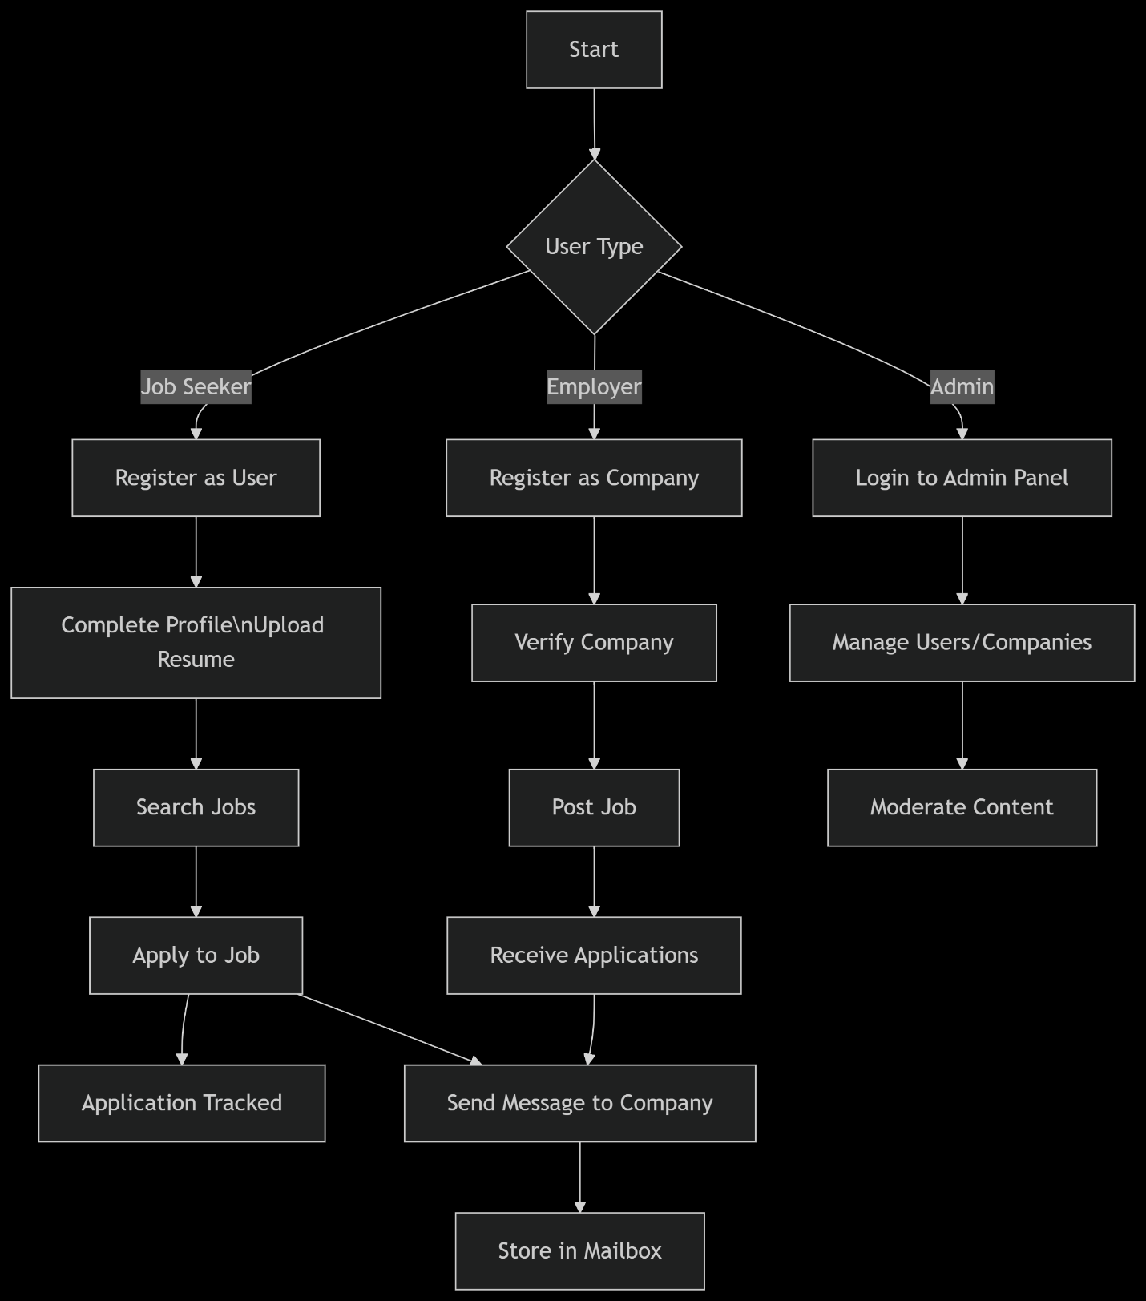

**4.2 Entity-Relationship Diagram:**

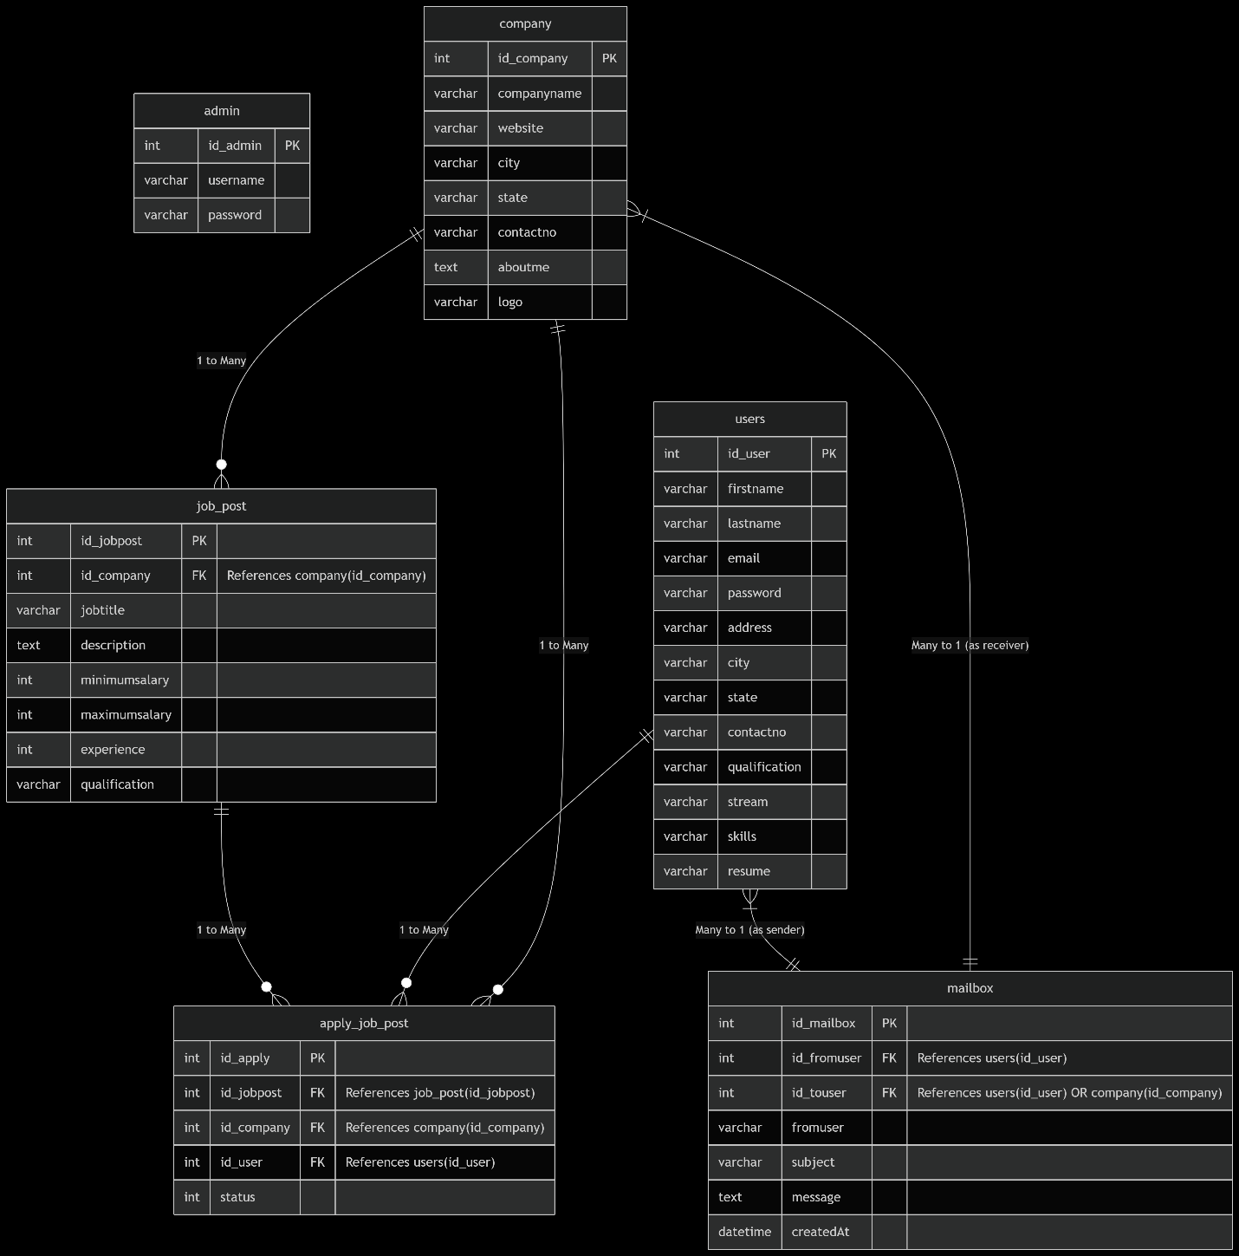

**4.3 Schema Diagram:**

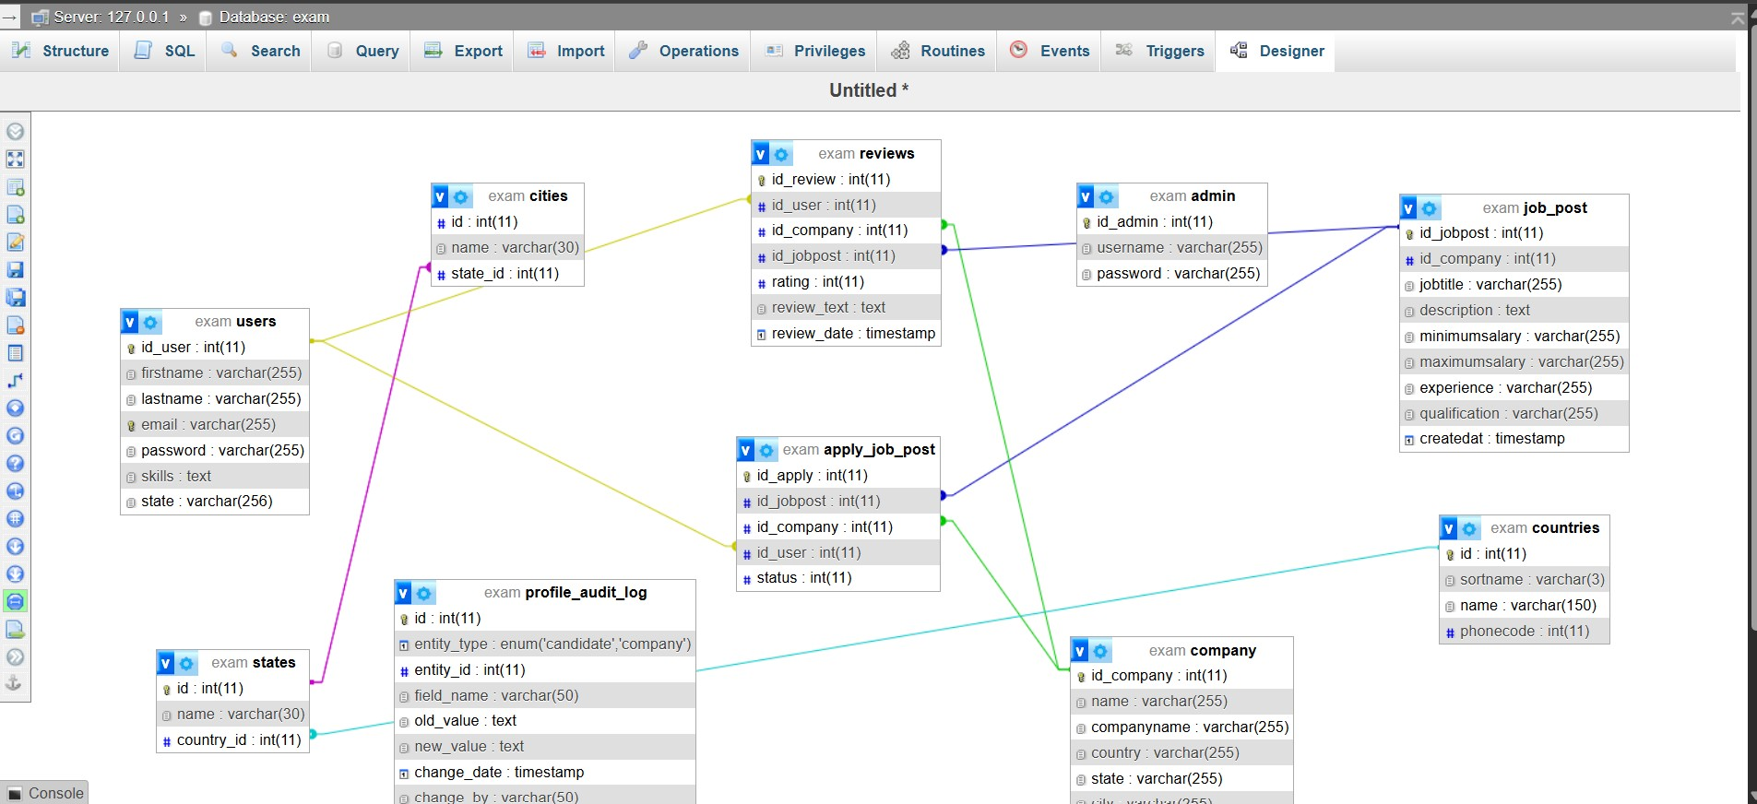

**SYSTEM DESIGN**

**5.1 Features:**

* Secure user registration and login mechanism for three distinct roles: **Job Seeker**, **Employer**, and **Administrator**.
* Role-specific dashboards and privileges ensure streamlined access to relevant functionalities.
* Users can build a comprehensive profile, upload resumes, and showcase their professional skills and experiences.
* Enables users to filter jobs based on keywords, location, category, and company.
* Provides a centralized view of all registered users, job posts, and system statistics.
* Encrypted password storage and secure session management.
* Personal information and resumes are protected from unauthorized access using standard best practices.

**5.2 User Login Sequence**

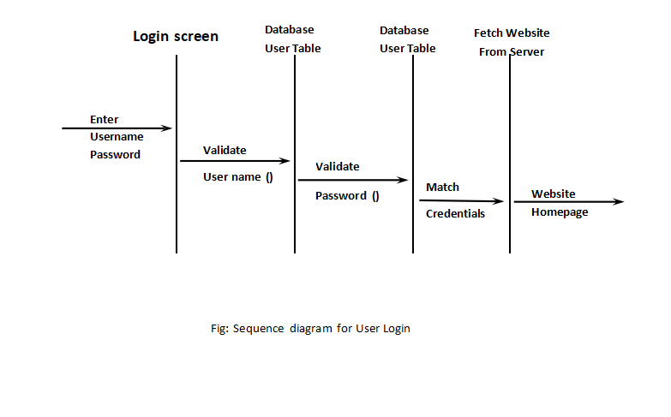

**5.3 Project Showcase (Front-end): Using HTML CSS PHP JS**

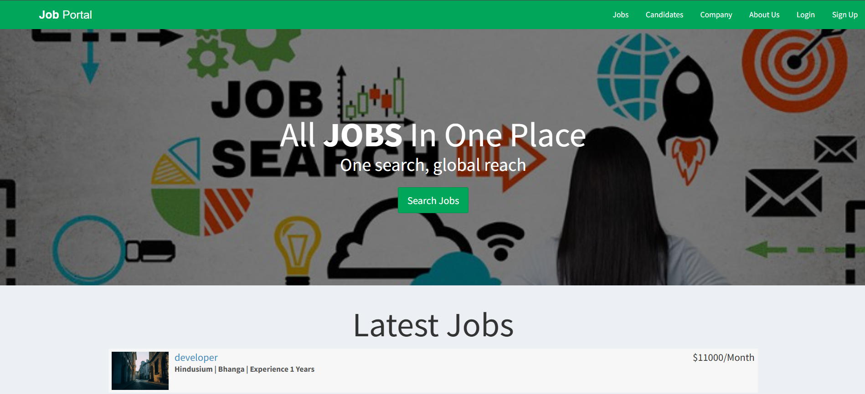

Fig: Home Page

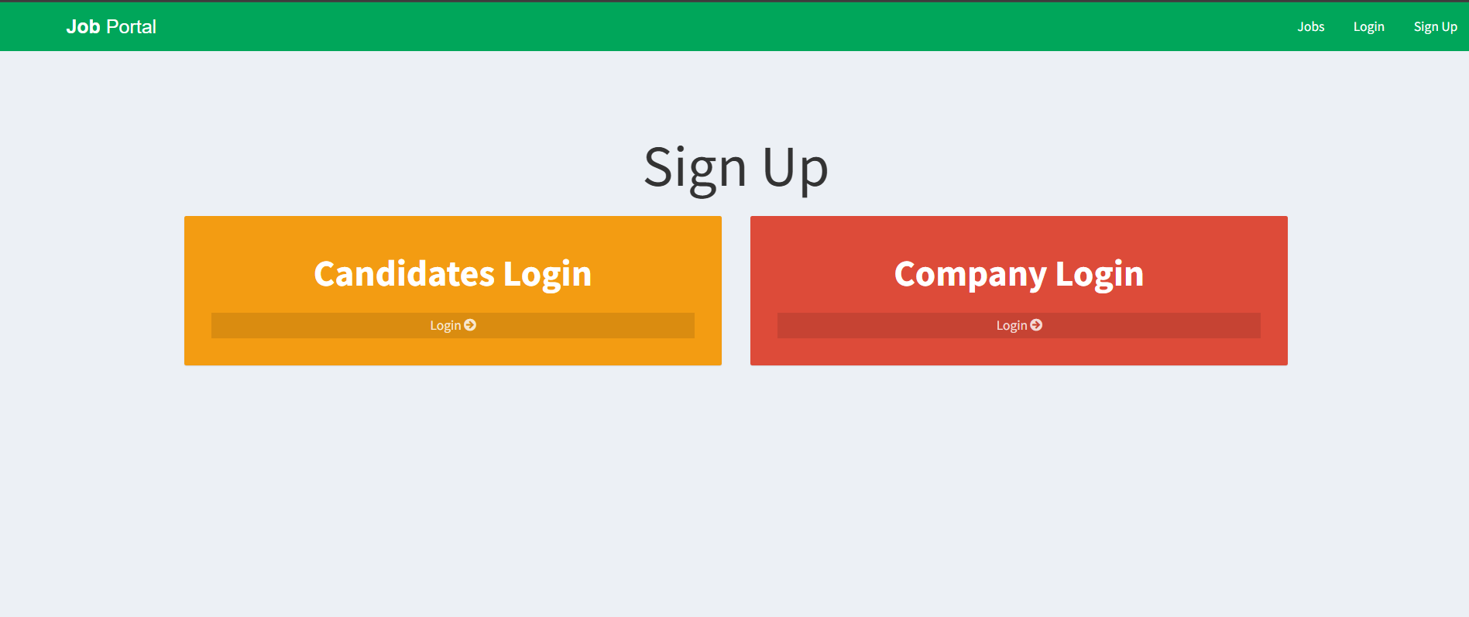

Fig: Login Page

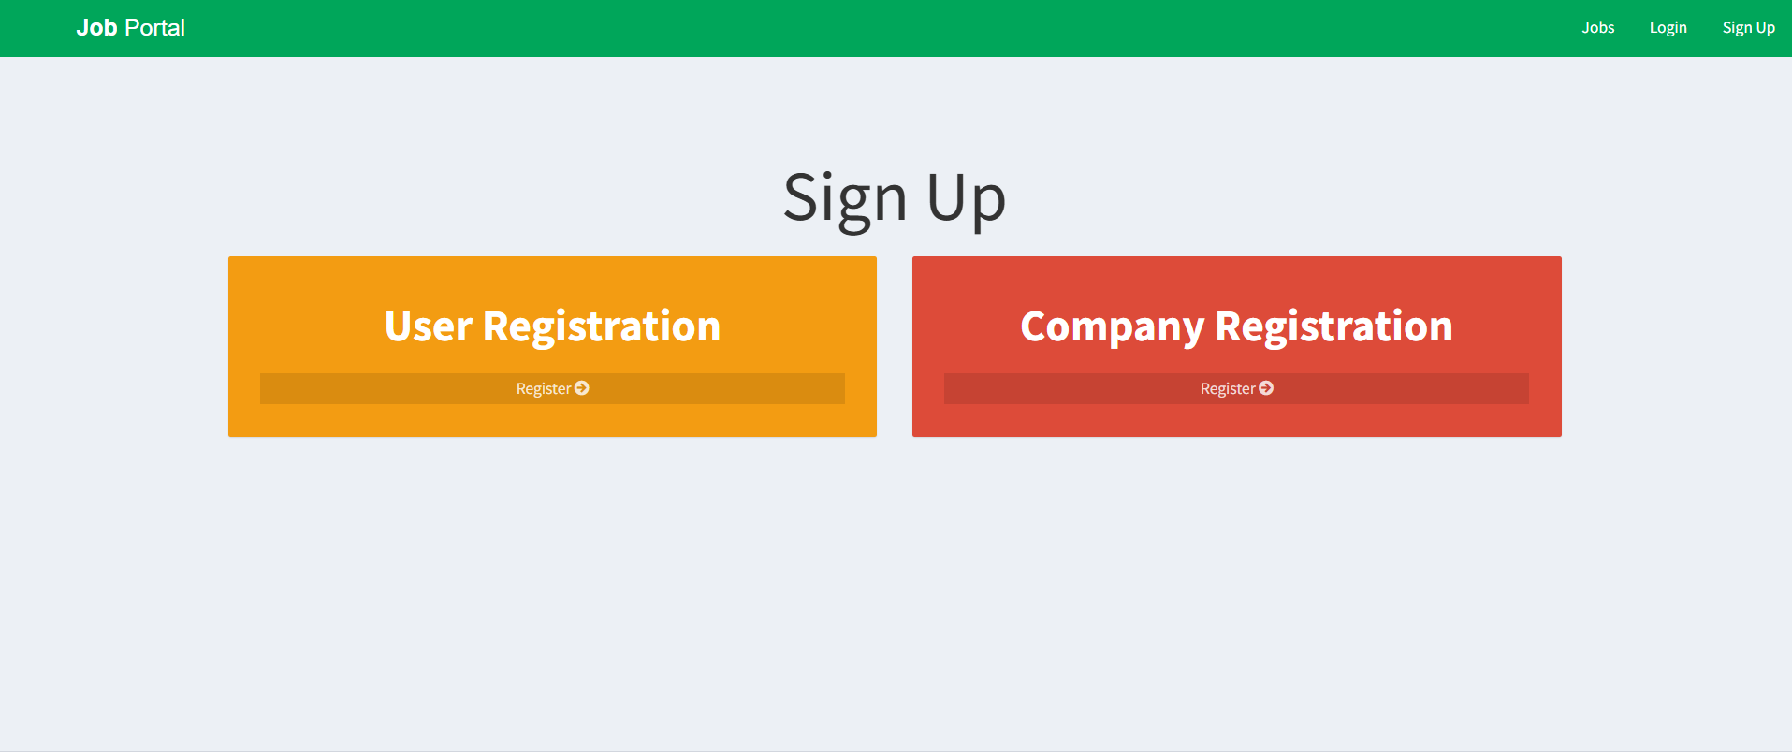

Fig**:** Registration Page

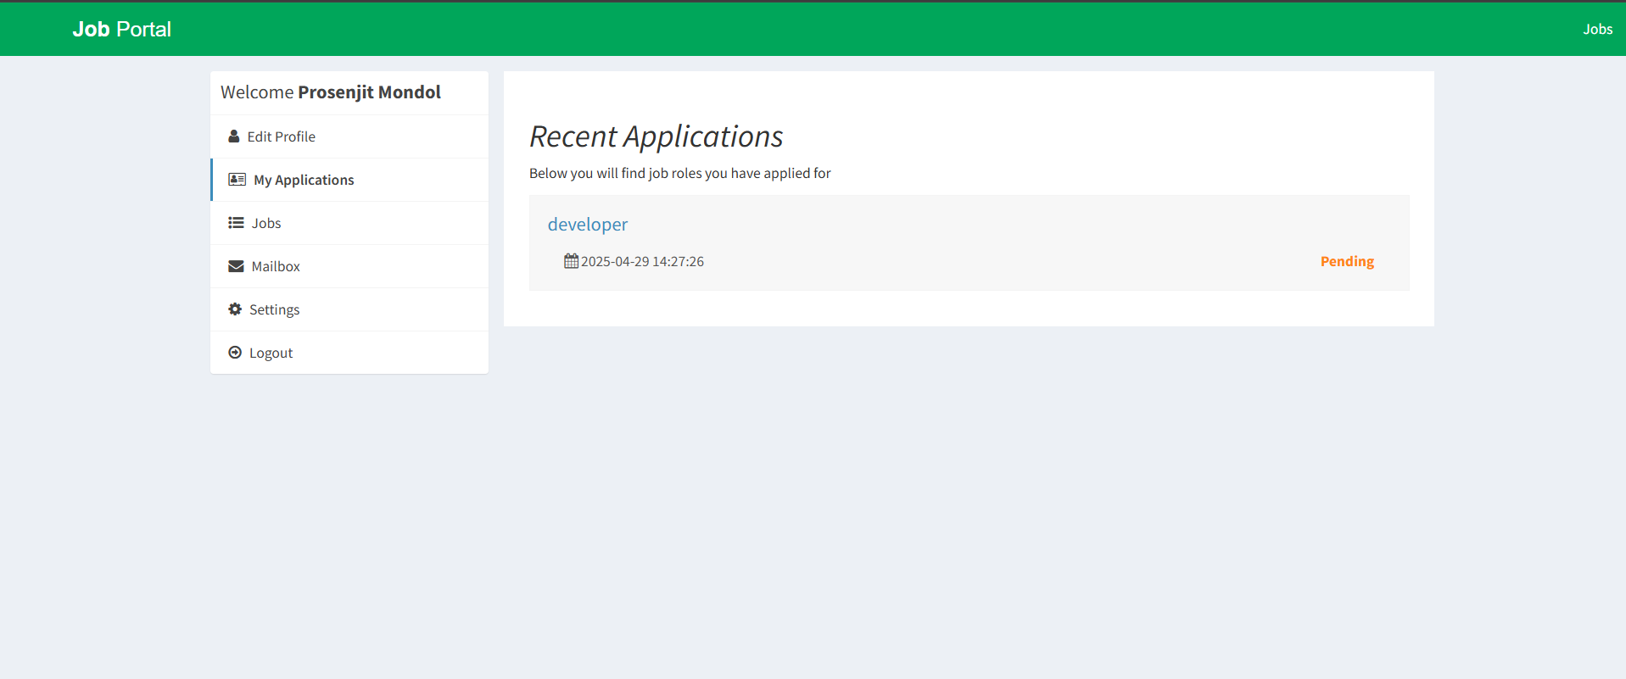

Fig: Candidate Homepage

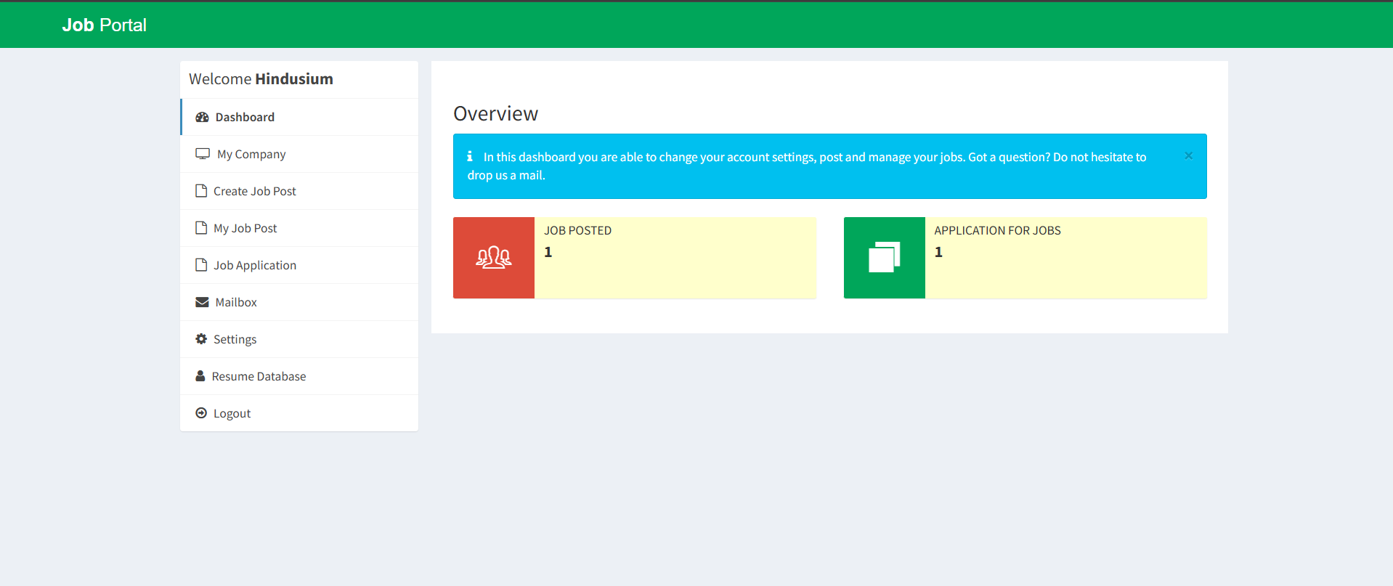

Fig: Company Homepage

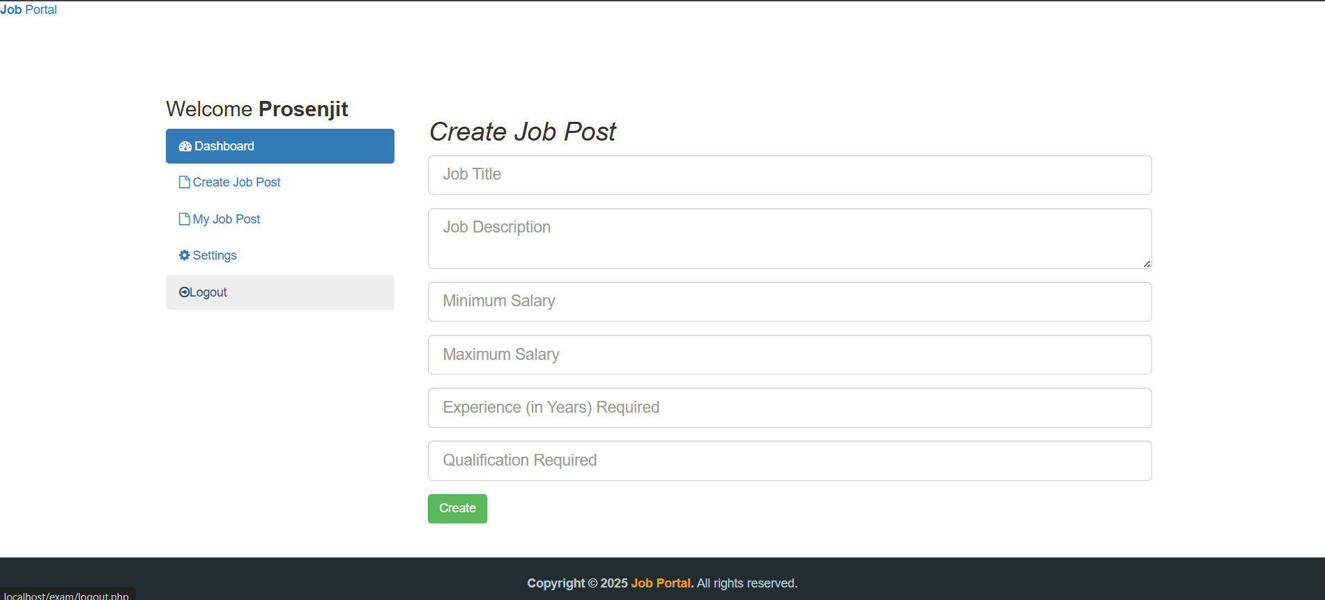

Fig: Job Post

**5.4 Project Showcase (Backend): MySQL**

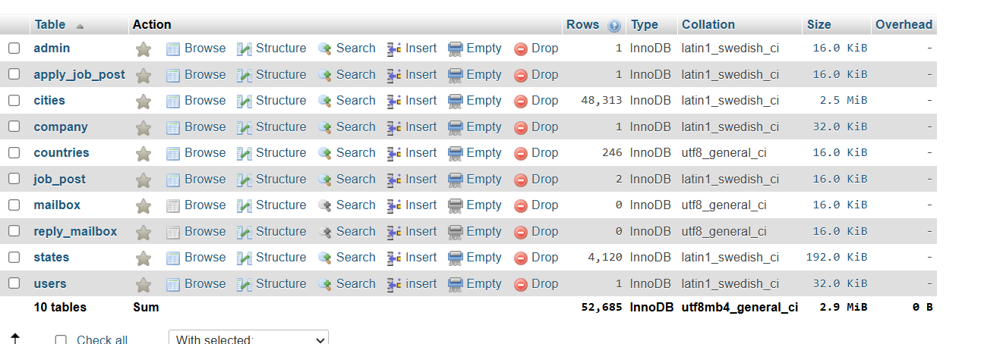

Fig: Table

**CODING**

**6.1 File-Structure: From VS Code**

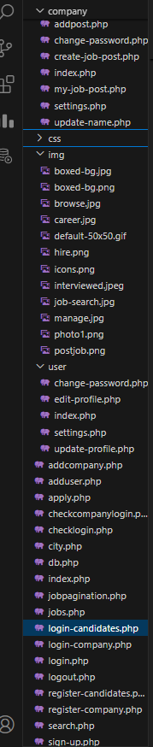

**CONCLUSION**

In an era defined by digital transformation and rapid technological evolution, the development of this Job Portal stands as a testament to the power of purposeful innovation. This project has successfully bridged the gap between job seekers and employers by offering a comprehensive, secure, and user-friendly platform that facilitates career opportunities and talent acquisition with remarkable efficiency.

Through the integration of modular features—such as role-based access control, real-time application tracking, and robust communication channels—the portal not only streamlines the recruitment lifecycle but also enhances the user experience for all stakeholders. From the meticulous design of its data architecture to the logical flow of its functionalities, every component has been thoughtfully engineered to ensure both scalability and reliability.

Moreover, this project has provided invaluable practical insights into full-stack development, relational database design, user interface creation, and administrative governance. It has honed not just technical skills but also analytical thinking, teamwork, and problem-solving abilities, making it a significant academic and professional milestone.

Ultimately, this Job Portal is more than a project—it is a digital solution with real-world applicability, designed to empower individuals and organizations alike. As we envision future enhancements through AI-driven job matching, analytics, and automation, this platform lays a strong foundation for continued innovation in the employment ecosystem.